Book

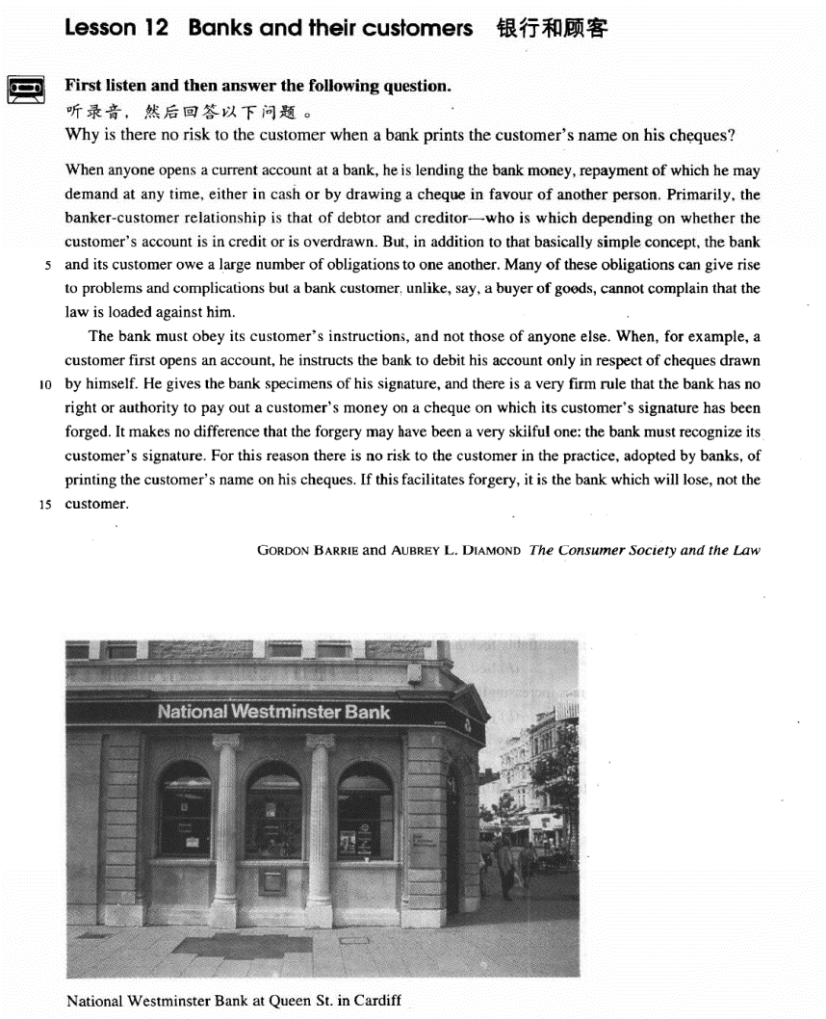

课文

When anyone opens a current account at a bank, he is lending the bank money, repayment of which he may demand at any time either in cash or by drawing a cheque in favour of another person.

任何人在银行开一个活期账户，就等于把钱借给了银行。这笔钱他可以随时提取，提取的方式可以是取现金，也可以是开一张以他人为收款人的支票。

Primarily, the banker-customer relationship is that of debtor and creditor -- who is which depending on whether the customer's account is in credit or is overdrawn.

银行与储户的关系主要是债务人和债权人的关系。究竟谁是债务人谁是债权人，要看储户是有结余还是透支。

But, in addition to that basically simple concept, the bank and its customer owe a large number of obligations to one another.

除了这一基本的简单的概念外，银行和储户彼此还需承担大量义务。

Many of these obligations can give rise to problems and complications but a bank customer, unlike, say, a buyer of goods, cannot complain that the law is loaded against him.

其中许多义务往往引起问题和纠纷。但是储户不能像货物的买主那样来抱怨法律对自己不利。

The bank must obey its customer's instructions, and not those of anyone else.

银行必须遵照储户的嘱托办事，不能听从其他人的指令。

When, for example, a customer first opens an account, he instructs the bank to debit his account only in respect of cheques drawn by himself.

比如，储户首次在银行开户时，嘱咐银行他的存款只能凭本世人签字的支票来提取。

He gives the bank specimens of his signature, and there is a very firm rule that the bank has no right or authority to pay out a customer's money on a cheque on which its customer's signature has been forged.

他把自己签名的样本交给银行，对此有一条非常严格的规定：银行没有任何权利或理由把储户的钱让伪造储户的支票取走。

It makes no difference that the forgery may have been a very skillful one: the bank must recognize its customer's signature.

即使伪造得很巧妙，也不能付款，因为银行有责任辨认出其储户的签名。

For this reason there is no risk to the customer in the practice, adopted by banks, of printing the customer's name on his cheques.

因此，某些银行已采用把储户印在支票上的作法。这种做法对储户毫无风险。

If this facilitates forgery, it is the bank which will lose, not the customer.

如果因这种作法出现了伪造的话，受损失的将不是储户，而是银行。

词汇讲解

* **template** [pʌŋktʃʊ'ælətɪ]
* **template** show.

### current

* **current** ['kʌrənt] adj. 当前的，现在的，流行的
* **current** problems
* **current** events / affairs
* the **current** president

“**银行相关**”：

**current account** 活期账户

**checking account** 活期账户

**savings account** 定期账户

**deposit account** 定期账户

**open an account**  开户

**close an account**  销户

**deposit** / **bank** v.存款

* You’d better **deposit** / **bank** your money.

**draw / withdraw … from …** 取款

**take … out of …** 取款

* He **drew / withdrew** $100 **from** his bank (account).
* He **took** $100 **out of** his bank (account).

**overdraw** v.透支

* My account is **overdrawn** by $200.

**cash** / **encash** v.兑换现金

* **to cash / encash a check** 把支票兑换成现金

### debtor

* **debtor** ['detə(r)] adj. 债务人，借方

“**银行相关**”：

**debtor** n. **英文解释：**person who owes money to sb. 债务人，借方

**creditor** n. **英文解释：**person to whom money is owed 债权人，贷方

**debit** v. 把……计入借方，记上客户支出的钱

* **Debit** $100 **against** Mr. Smith’s account. 从账户中取走…
* **Debit** Mr. Smith’s account **with** $100. 从账户中取走…

**debit** n. 账户的借方；账户中提取的款项

**credit** v. 把……计入贷方，记上客户存入的钱

* **Credit** Mr. smith’s account **with** $100. 存入…

**credit** n. 账户的贷方；账户中存入的款项

* Your account is in **credit**. 账户中有余额

### obligation

* **obligation** [7ɒblɪ'geɪʃn] adj. 责任，义务

**obligation to n. / to do sth** 对于…的义务/有义务去做…

* America’s **obligation to** its allies
* Employers **have an obligation / are under an obligation to treat** all employees equally.

**meet / honor / fulfill one’s obligation** 履行义务

**sense of obligation** 责任感

**legal obligation** 法律义务

**moral obligation** 道德义务

**mutual / reciprocal obligation** 相互义务

**【近义词】【辨析】**

**duty** （强调主动承担，强调基于道义、良心上的）

**obligation** （强调不得不履行的责任、义务）

**responsibility** （强调为某事负责）

### complication

* **complication** [7kɒmplɪ'keɪʃn]n. 复杂的情况，纠纷

**complication** n. 纠纷

* **complications** between two parties / countries …之间的纠纷
* legal **complications** 法律纠纷
* avoid **complications** 避免纠纷
* cause **complications** 导致纠纷
* produce further **complications** 产生进一步的纠纷

**complication** n.并发症

* If diabetes is not treated properly, **complications** will set in.

**【同根词】**

**complicate** vt. 使复杂化；使恶化；使卷入

**complicated** adj. 难懂的，复杂的

**【词根】**

“**plic**” = **fold** 折叠

**implicate** vt. 使卷入；涉及；暗指；影响

* He was **implicated *in***the crime.

**explicate** v. <正>解释，说明

* The teacher is **explicating** an abstruse poem.

**duplicate** 复制

* He **duplicated** his former mistakes.

**supplicate** 恳求

* I **supplicated** her forgiveness.

### specimen

* **specimen** ['spesɪmən] n. 样品，标本

**specimen** / **sample** n. 样品，标本

* a **specimen** / **sample** signature
* a blood **specimen** / **sample**
* a urine **specimen** / **sample**

**sample** n. 试用品

* **samples** of a new shampoo

### adopt

* **adopt** [ə'dɒpt] v. 领养；采取，采用；正式批准

表达“**领养**”：

* **adopt** an orphan
* **adopted** son
* **adoptive** parents 养父母
* **foster-parents** 养父母

表达“**采取、采用**”：

* **adopt** a new idea
* **adopt** a new technique

表达“**正式批准**”：

* The Senate unanimously **adopted** the committee’s proposals.

**【同根词】**

**adoption** n. 领养；采纳，采用

* This textbook has **adoptions** in many countries.

**【形近词】**

**adept** adj. 熟练的，内行的

**be adept at / in …** 在…很熟练

**adapt** v.（使）适应；改编

* She quickly **adapted *to***the new climate.
* The movie **was adapted *from***a novel.

### facilitate

* **facilitate** [fə'sɪlɪteɪt] v. 使某事更容易
* Modern devices **facilitate** domestic work.

**【同根词】**

**facility** n.（常用复数）（使事情便利的）设备，设施

* drainage **facilities**
* medical **facilities**
* recreational **facilities**
* public health **facilities**
* lodge and eating **facilities**

**facile** adj. easily obtained or achieved (and so not highly valued) 容易得

到的（因而没有太大价值的）

* a **facile** success

**【词根】**

“**fac**” = make 做

**manufacture** 制造

**benefactor** n. 恩人；捐助者；施主

**malefactor** n. 作恶者；罪犯；坏人

**【词根】**

“**-ile**” 易于的

**fertile** adj. 富饶的，肥沃的；能生育的

**fragile** adj. 脆的；易碎的

**facile** (“fac” + “ile”)

课文讲解

# （第一段）

# When anyone opens a current account at a bank, he is lending the bank money, repayment of which he may demand at any time either in cash or by drawing a cheque in favour of another person.

**语法分析：**

When anyone opens a current account at a bank（when...时间状语从句）, he is lending the bank money, *repayment of which he may* ***demand*** *at any time, either in cash or by drawing a cheque in favour of another person**（方式状语）*. *（repayment of which… 定语从句，which修饰money，repayment of which做****demand****的宾语）*

知识点（1）

**lend sth. to sb.** 把…借给某人 （借出去）

= **lend sb. sth.**

**loan sth. to sb.** 把…借给某人 （借出去）

= **loan sb. sth.**

**borrow sth. from sb.** 向某人借…（借进来）

**~~borrow sb. sth.~~** X错误搭配

表达“**你能不能借给我 100 块钱？**”：

* ~~Would you borrow me ￥100?~~ X错误搭配
* Would you **lend** me ￥100?
* Would you **lend** ￥100 **to** me?
* May I **borrow** ￥100 **from** you?
* ~~May I borrow you ￥100?~~ X错误搭配

知识点（2）

**【课文句型提炼】**

**when anyone …, he is …** 无论是谁（做某事），就等于在……

* **造句**：无论是谁试图徒步穿越这个山口，就等于在生命冒险。
* **When anyone** tries to cross the pass on foot, **he is** risking his life.

知识点（3）Lesson03-32

**语法：**“名词 + 介词 + 关系代词” 引导**非限定性定语从句**；前提是定语从句修饰的不是先行词本身，而是先行词相关的东西或一部分

* **造句**：他有两个儿子，其中的一个死于战火。
* He has two sons, **one of whom** died in the war.
* **造句**：演讲者提了 (pose) 四个问题，它们的答案被证明非常具有启发性(illuminating)。
* The speaker posed four questions, **the answers to which** proved very illuminating.
* She hurried home to feed her cats, **one of which** had just had kittens.
* This echo-location in bats is often compared with radar, **the principle of which** is similar.
* The most valuable find of all was the ship's log book, **parts of which** it was still possible to read.

知识点（4）

**repayment of …** 偿还、归还

* the **repayment of** debt 债务偿还

**repay sb. sth.** 归还某人某事

= **repay sth. to sb.** 把某事归还某人

**pay sb. back** 归还某人某事

**pay back sth.** 归还某事

* I’ll **pay** you **back** tomorrow.

**pay off one’s debts** 还清债务

**clear one’s debts**  清偿债务

**give sb. a refund** 给某人退款

* We’ll **give you a refund** if you’re not entirely satisfied.

**reimburse sb.** 报销

* Pay for the hotel room when you leave, and the company will **reimburse** you later.

知识点（5）

**in favor of …**（支票）以某人/某部门为受款人

* Checks should be written / drawn **in favor of** School.

# Primarily, the banker-customer relationship is that of debtor and creditor -- who is which depending on whether the customer's account is in credit or is overdrawn.

**语法分析：**

Primarily, the banker-customer **relationship** is **that**（代替**relationship**） of debtor and creditor—who is which（主语从句） *depending on whether the customer's account is in credit or is overdrawn*. （独立主格）

知识点（1）

表达“主要的”：副词同义替换

**Primarily**

**Principally**

**Chiefly**

**Mainly**

**Largely**

**Above all**

**First and foremost**

知识点（2）

the banker-customer relationship is that of debtor and creditor

**相当于：**the **relationship between / of** banks and customers

知识点（3）Lesson03-57

debtor and creditor

**语法：**语义相对的名词并列，常省略冠词

* **Father and son** went to New York by a morning train.
* We are **brother and sister**.
* **Husband and wife** are talking about the boy’s future.
* Please pass me **pencil and paper**.
* **heart and soul**
* **knife and fork**
* the relation between **teacher and student**
* the conflict between **mother and son**

知识点（4）Lesson03-29

**whether和if 从句区别：**

表示“是否”时不能用 if 的几种情况：

**1）.主语从句位于句首时，不能用 if**

* *~~If she likes the present~~* ~~is not clear to me.~~ X错误
* It is not clear to me ***if / whether*** *she likes the present*. √ （改正，放在句中）
* ***Whether*** *she likes the present* is not clear to me. √ （改正，句首改成whether）

**2）.引导表语从句时，不能用 if**

* ~~The question is~~ *~~if~~* ~~we have enough money.~~ X错误
* The question is ***whether*** *we have enough money.* √改正

**3）.引导同位语从句时，不能用 if**

* ~~You have yet to answer my question~~ *~~if~~* ~~I can count on your help.~~ X错误
* You have yet to answer my question ***whether*** *I can count on your help*. √改正

**4）.作介词宾语时，不能用 if**

* ~~He was worrying about~~ *~~if~~* ~~he had hurt her feelings.~~ X错误
* He was worrying about ***whether*** *he had hurt her feelings*. √改正

**5）.引导动词不定式时，不能用 if**

* ~~I don’t know~~ *~~if to~~* ~~see my doctor today.~~ X错误
* I don’t know ***whether to*** *see my doctor today*. √改正

**6）.直接跟 or not 时，不能用 if**

* ~~Please tell me~~***~~if~~*** *~~or not~~* ~~you agree.~~ X错误
* Please tell me ***whether or not*** *you agree*. √改正
* Please tell me ***if*** *you agree* ***or not*.** √改正

知识点（5）

**be overdrawn** 有赤字

= **be in the red**

* Your account **is overdrawn** / **in the red**.

# But, in addition to that basically simple concept, the bank and its customer owe a large number of obligations to one another.

知识点（1）

表达“**除了…之外，还…**”：

**in addition to …**

**besides …**

**as well as …**

**together with …**

**along with …**

**apart from …**

**aside from …**

知识点（2）

**owe sth. to sb.** 前某人某事

= **owe sb. sth.**

**owe obligations to sb.** 对某人有义务

= **have obligations to sb.**

* Parents **owe / have obligations to** their children. I owe you (a lot).
* You **owe** him an apology.
* You **owe** him an explanation.

知识点（3）

**one another**

**each other**

当代英语中可替换，没有限制

# Many of these obligations can give rise to problems and complications but a bank customer, unlike, say, a buyer of goods, cannot complain that the law is loaded against him.

**语法分析：**

Many of these obligations can give rise to problems and complications but a bank customer, *unlike, say, a buyer of goods**（插入语）*, cannot complain that the law is loaded against him.

知识点（1）Lesson03-04

**give rise to sth.** (fml.) 导致……（正式表达）

* The president’s absence has **given rise to** speculation about his health.
* This can **give rise to** curious situations, as it did in the case of Alfred Bloggs who worked as a dustman for the Ellesmere Corporation.

**【近义词组】**表达“**导致**”：

**cause …**

**effect …**

**result in …**

**bring about  …**

**lead to …**

**contribute to …**

**account for …**

**set up …**

* The slump on Wall Street **set up** a chain reaction in stock markets around the world.

**produce** / **create** / **generate**

* His announcement **produced** / **created** / **generated** gasps of amazement.

**trigger** / **spark** / **precipitate**

* One small error **triggered** / **sparked** / **precipitated** the calamity.

知识点（2）

**sth. is loaded against …** **英文解释：**used to say that a system, situation, or organization is unfair and some people have a disadvantage 对……不公平

* The justice system **is loaded against** ethnic minorities.

**【近义词组】**表达“**对……有偏见**”： Lesson03-53

**be prejudiced against …**

**be biased against …**

* The early Christian church **was prejudiced / biased against** Jews.
* He **seemed** a bit **biased against** women in my opinion.  （偏见）
* The fact that the policeman **was prejudiced against** foreigners could not be recorded in the official files.

**【辨析】**

**be biased *in favor of / toward(s)*…**对…偏袒的

**be partial *to / toward(s)*…**对…偏袒的

* The judge **is biased in favor of** the plaintiff. （偏袒）
* The referee **was** clearly **partial to** the other side. （偏袒）

# （第二段）

# The bank must obey its customer's instructions, and not those of anyone else.

知识点（1）

**obey instructions** 遵守命令

**take instructions**  接受命令

**follow instructions**  按照命令

**await instructions** 等候命令

# When, for example, a customer first opens an account, he instructs the bank to debit his account only in respect of cheques drawn by himself.

**语法分析：**

When, for example（插入语）, a customer first opens an account（when...时间状语从句）, he instructs the bank to debit his account *only in respect of（=about） cheques drawn by himself**（后置定语）*.

知识点（1）

**【近义词组】**表达“**关于**”：介词短语

**in respect of**

**with respect to**

**with regard to**

**concerning**

**regarding**

**respecting**

* US foreign policy **~~~** Cuba

# He gives the bank specimens of his signature, and there is a very firm rule that the bank has no right or authority to pay out a customer's money on a cheque on which its customer's signature has been forged.

**语法分析：**

He gives the bank specimens of his signature, and there is a very firm rule **that** the bank has no right or authority to pay out a customer's money on a cheque on which its customer's signature has been forged（which...定语从句）. （**that**... 同位语从句）

知识点（1）

**signature** n. 署名；签名；信号

**autograph** n. （名人的）亲笔签名

* I’ve got lots of famous actors' **autographs**.

**sign** v. 签署

* Where do you want me to **sign** my name?

**sign for …** 签收

* Could you **sign for** this package, please?

**initial** vt. 用姓名的首字母签名

* The memo has been **initialled** / **initialed** by the president.

知识点（2）

**authority** n. [U] **英文解释：**right to act in a specific way 职权，权限

* Only the treasurer has **authority** to sign checks.

知识点（3）

**pay out 英文解释：**to pay a lot of money for something 支付（大笔的钱）

* We’re **paying out** $300 a month on our mortgage.

# It makes no difference that the forgery may have been a very skillful one: the bank must recognize its customer's signature.

知识点（1）

**make a difference**  有用

**make some difference**  有点用

**make no difference** 没用

# For this reason there is no risk to the customer in the practice, adopted by banks, of printing the customer's name on his cheques.

**语法分析：**

For this reason（介词短语做状语） there is no risk *to the customer* in the practice, *adopted by banks（插入语）*, of printing the customer's name on his cheques（介词of引出同位语）.

知识点（1）

**【近义词组】**表达“**因此**”：

**for this reason**

**thus**

**therefore**

**ergo**

**as a result**

**as a consequence**

**so**

**hence**

**thereupon**

**accordingly**

**consequently**

**in consequence**

知识点（2）

**risk *of*** 做某事的风险

* the **risk *of***serious injury

**risk *to*** 对某事的风险

* There is no **risk *to*** customers.

知识点（3）

**practice** n.习惯性的做法，惯例

**the practice of doing sth.** 做某事的惯例

* **the practice of** closing shops on Sundays
* **the practice of** dumping waste into the sea

# If this facilitates forgery, it is the bank which will lose, not the customer.

**语法分析：**

If this facilitates forgery（if... 条件状语从句）, it is（强调句） the bank which（强调句） will lose, not the customer.

知识点（1）

**facilitate …** v. 使某事更容易

**【近义词组】**

**ease / smooth the way for …**使某事更容易

* The agreement will **ease / smooth the way for** other countries to join the EU.

知识点（2）

**一般强调句：**

**it is/was +被强调部分 + that/who(m)+ 从句** **可以强调句子中任何非谓语的部分；只用于书面语**

**特殊强调句：**

**it is … which …**（尤其用于科技、说明文体）

* **It is** heat **which** makes matter expand and melt.
* **It is** the release of nuclear energy within the Sun **which** enables it to send out so much energy to the earth.

知识点（3）**【课文句型提炼】**Lesson04-05

**if …, it is … that / which / who(m) …, not …**

如果…，那么是…，而不是…

* **If** this facilitates forgery, **it is** the bank **which** will lose, **not** the customer. **If** there is one—which I take leave to doubt—then **it is** older people **who** create it, **not** the young themselves.